Add a form to index.html that allows the user to select a team's starting lineup for a game.

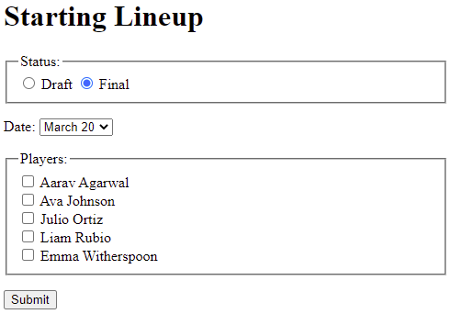

The form should:

* Use a <p> to surround related labels, form widgets, and fieldsets
* Use a <fieldset> and <legend> with radio buttons for choosing Draft or Final. The radio buttons' name attribute should be "status" with values "Draft" and "Final".
* Make the Final radio button checked by default
* Add a <label> to each radio button so clicking the label text selects the radio button
* Use a drop-down with the following dates: March 20, March 24, April 2, April 6, April 13. The <select> name attribute should be "gameDate", and each <option> should use a value identical to the option's date.
* Use a <fieldset> and <legend> with check boxes for choosing players: Aarav Agarwal, Ava Johnson, Julio Ortiz, Liam Rubio, Emma Witherspoon. The name attribute "player" should be used for all check boxes, and each check box should use a value identical to the player's name.
* Add a <label> to each checkbox so clicking the label text selects the checkbox
* Use a submit <input> with value "Submit"